WK 12 Code Challenge Worksheet – Maximo Antigua

Add a screenshot of the tny_July.html file displayed in the browser, after completing Step 11. Include the browser address bar in the screenshot.

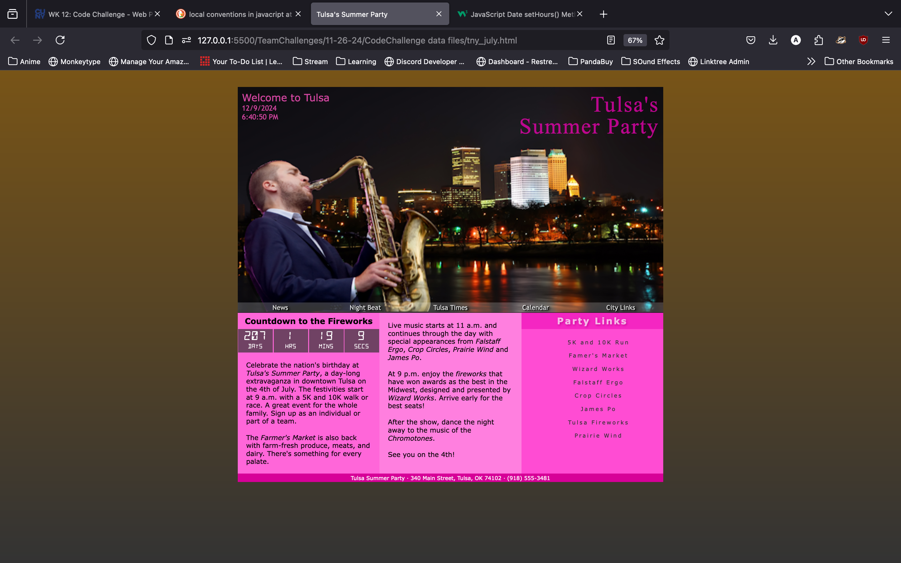

Add a second screenshot of the tny_July.html file displayed in the browser showing the countdown clock changes every second as it counts down the time until the start of the fireworks at 9:00 pm on the 4th July.

